LAB EXPERIMENT RECORD

Set 3: Employee Performance Evaluation

Department | B. Tech AI&DS
Course Code / Course Name | DSA0602 / Data Handling and Visualization
Experiment | Data Visualization using R
Name | Peram Mahitha
Register Number | 192524136
Date | 29 September 2026
Day | Tuesday

Dataset 1: Monthly Sales

Month | Sales ($)
January | 15,000
February | 18,000
March | 22,000
April | 20,000
May | 23,000

Dataset 2: Employee Performance

Employee ID | Department | Years of Service | Performance Score
1 | Sales | 5 | 85
2 | HR | 3 | 92
3 | Marketing | 7 | 78

4 | Sales | 4 | 90
5 | HR | 2 | 76

Program 1: Line Chart – Monthly Sales Trend

Aim

To create a line chart to visualize the monthly sales trend with appropriate labels and legend.

R Program

month <- c("January", "February", "March", "April", "May") sales <- c(15000, 18000, 22000, 20000, 23000)

data |  |  | <- |  |  | data.frame(month, | sales)
plot(data$sales,
type |  |  |  |  |  | = | "o",
col |  |  |  |  |  | = | "blue",
xaxt  xlab |  |  |  |  |  | =  = | "n",  "Month",
ylab |  |  |  |  | = | "Sales | ($)",
main |  | = |  |  |  | "Monthly Sales | Trend")
axis(1, | at |  |  | = |  | 1:5, labels = | data$month)
legend("topleft",
legend |  |  |  |  |  | = | "Sales",
col |  |  |  |  |  | = | "blue",
lty  pch = 1) |  |  |  |  |  | = | 1,

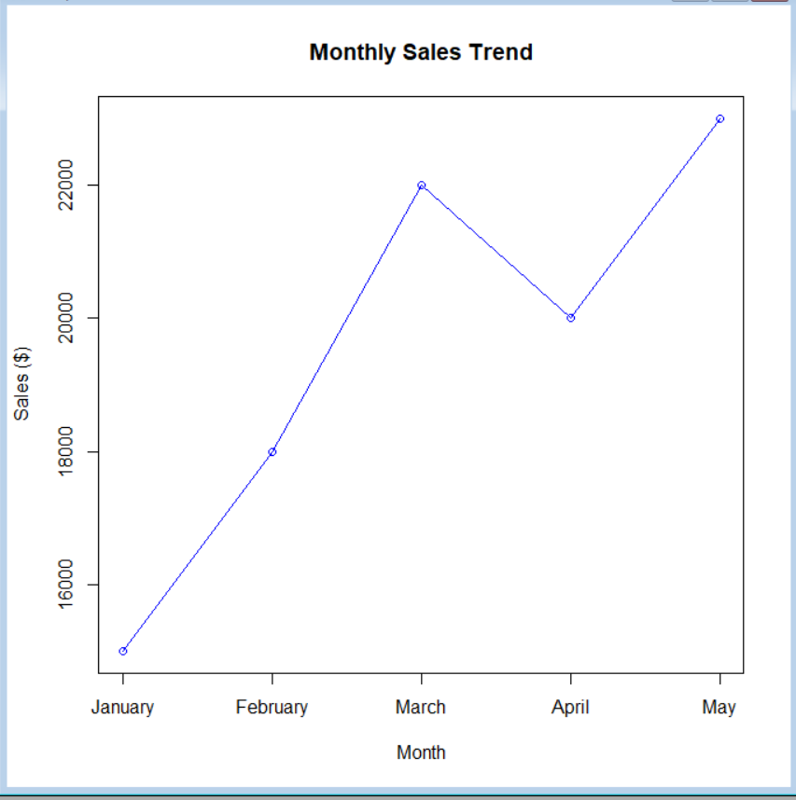

Observation

Sales generally increased from January to May, with a small decrease in April. The highest sales were recorded in May at $23,000.

Program 2: Bar Chart – Employee Distribution by Department

Aim

To create a bar chart showing the distribution of employees across different departments.

R Program

department <- c("Sales", "HR", "Marketing", "Sales", "HR") employee_data <- data.frame(department) dept_count <- table(employee_data$department)
barplot(dept_count,
main = "Employee Distribution by Department", xlab = "Department", ylab = "Number of Employees", col = "lightblue", ylim = c(0, max(dept_count) + 1))

text(x = seq_along(dept_count),
y = dept_count,
labels = dept_count, pos = 3)

legend("topright",
legend = names(dept_count), fill = "lightblue")

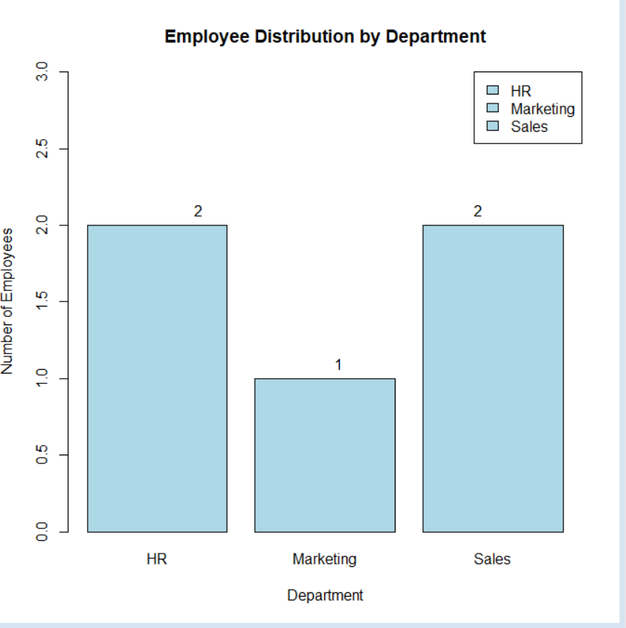

Observation

Sales and HR each have 2 employees, while Marketing has 1 employee.

Program 3: Scatter Plot – Years of Service vs Performance

Aim

To create a scatter plot to analyze the relationship between employees' years of service and their performance scores.

R Program

years <- c(5, 3, 7, 4, 2)
performance <- c(85, 92, 78, 90, 76) employee_data <- data.frame(years, performance)
plot(employee_data$years, employee_data$performance,
main = "Years of Service vs Performance Score", xlab = "Years of Service", ylab = "Performance Score",
pch = 19,
col = "blue")

text(employee_data$years, employee_data$performance,
labels = 1:5,
pos = 3)

abline(lm(performance ~ years, data = employee_data), col = "red", lwd = 2)

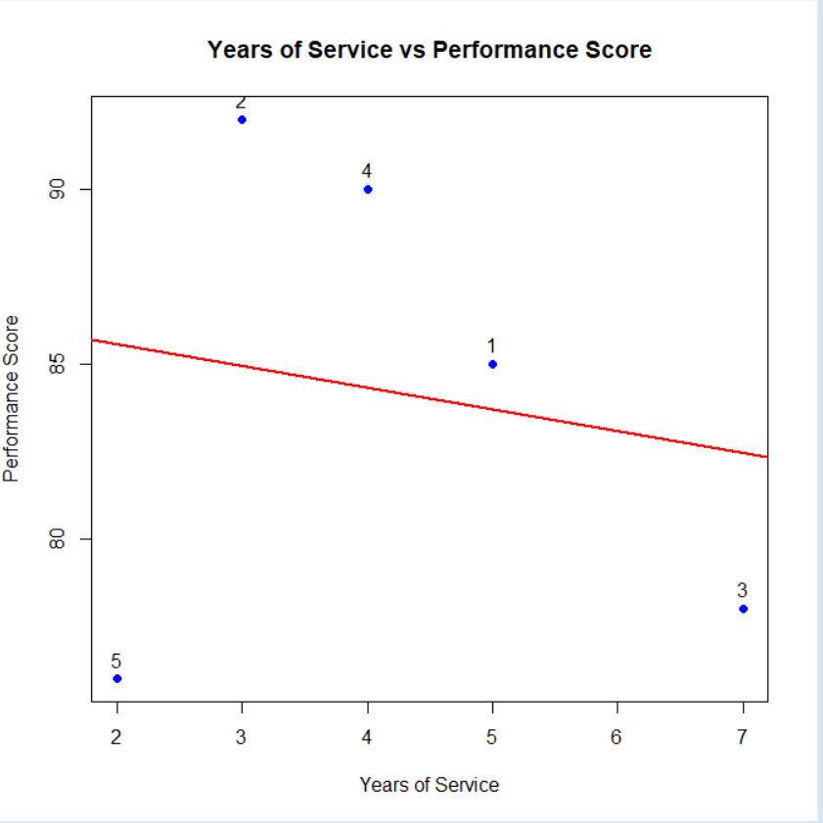

Observation

The scatter plot shows a negative relationship in this small dataset: employees with more years of service do not necessarily have higher performance scores. For example, the employee with 7 years of service has a score of 78, while an employee with 4 years has a score of 90.

Program 4: Tableau Dashboard

Aim

To develop an interactive Tableau dashboard containing the line chart and bar chart for employee performance analysis.

Procedure

Step 1: Open Tableau.

Step 2: Create the following datasets in Excel/CSV:

Sales Dataset

Month,Sales January,15000 February,18000 March,22000 April,20000 May,23000

Employee Dataset

Employee ID,Department,Years of Service,Performance Score 1,Sales,5,85
2,HR,3,92
3,Marketing,7,78 4,Sales,4,90 5,HR,2,76
Step 3: Open Tableau → Connect to Data → select the Excel/CSV file.

Step 4: Create Sheet 1 – Line Chart

- Drag Month → Columns
- Drag Sales → Rows
- Select Line chart
- Add title: Monthly Sales Trend Step 5: Create Sheet 2 – Bar Chart
- Drag Department → Columns
- Drag Employee ID → Rows
- Change aggregation to Count
- Select Bar Chart
- Turn on Show Mark Labels
- Add title: Employee Distribution by Department Step 6: Create Dashboard
- Click New Dashboard
- Drag the Line Chart onto the dashboard.
- Drag the Bar Chart below or beside it.
- Add suitable title: Employee Performance Evaluation Dashboard Step 7: Add filters/interactivity if required, such as Department.

Expected Dashboard

The dashboard allows users to visually explore:

- Monthly sales trends
- Number of employees in each department
- Department-wise employee distribution
- Interactive filtering

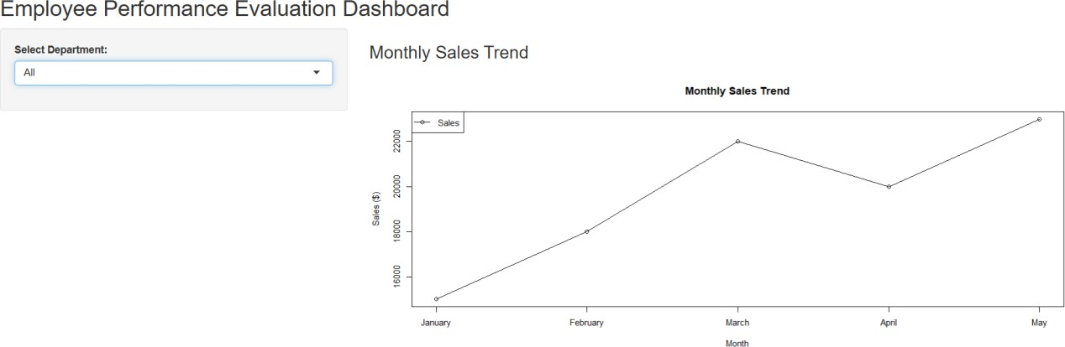
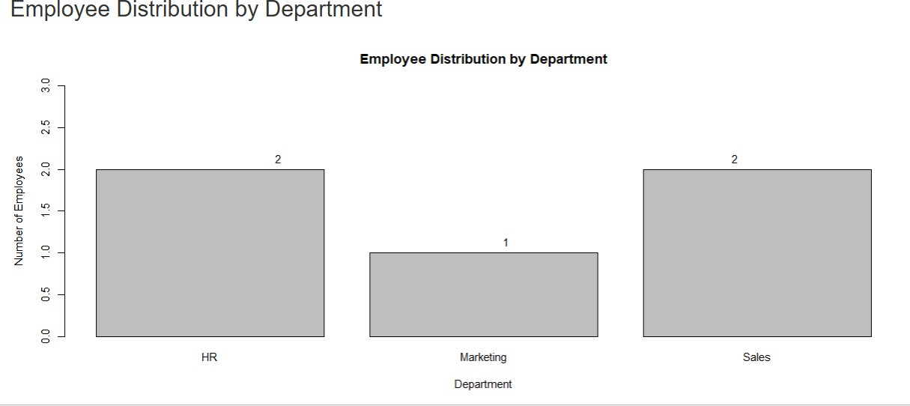

Overall Procedure

- Create/import the required datasets.
- Store the data in R data frames.
- Create a line chart for monthly sales.
- Create a bar chart for department distribution.
- Create a scatter plot for years of service versus performance score.
- Add labels, titles, legends, and trend line where required.
- Import the datasets into Tableau.
- Create the line and bar charts in Tableau.
- Combine the charts into an interactive dashboard.
- Analyze the resulting visualizations.

Result

The monthly sales trend, employee department distribution, and relationship between years of service and performance score were successfully visualized using R, and an interactive Tableau dashboard was designed using the line and bar charts.

Key R Functions Used

Function | Purpose
c() | Create vectors
data.frame() | Create data frames
plot() | Create line/scatter plots
axis() | Add/customize axes
legend() | Add legends
barplot() | Create bar charts
text() | Add labels to charts
table() | Count department frequencies
lm() | Create linear regression model
abline() | Add regression line

